6.10 The Knight Tour  
Specifications  
  
A knight’s tour is a sequence of moves of a knight on a chessboard such that the knight  
visits every square only once. If the knight ends on a square that is one knight’s move  
from the beginning square (so that it could tour the board again immediately, following  
the same path), the tour is closed, otherwise it is open.  
  
We recall that. a chess knight moves on the board “drawing” L letters. The knight's  
moves (left-hand side), and two open tours (center and right-hand side) are represented  
in the following picture.

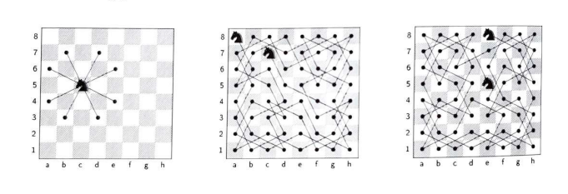  
  
  
The knight’s tour problem is the mathematical problem of finding a knigh  
Variations of the knight’s tour problem involve chessboards of different sizes 1  
usual (8 - 8), as well as irregular (non-rectangular) boards.  
  
Create a program to find a knight’s tour. Adopt a chess board of size N.N, where N   
is a pre-defined constant value, Read the starting cell position [i] [j] from standard  
input.